

# 

### Semester Two Examination, 2018

### Question/Answer booklet

# MATHEMATICS

**SOLUTIONS**

**SPECIALIST**

**UNITS 1 AND 2**

## Section Two:

## Calculator-assumed

|  |  |  |  |  |  |  |  |  |  |  |
| --- | --- | --- | --- | --- | --- | --- | --- | --- | --- | --- |
| Student number: In figures |  |  |  |  |  |  |  |  |  |  |

In words

Your name

## Time allowed for this section

Reading time before commencing work: ten minutes

Working time: one hundred minutes

## Materials required/recommended for this section

***To be provided by the supervisor***

This Question/Answer booklet

Formula sheet (retained from Section One)

***To be provided by the candidate***

Standard items: pens (blue/black preferred), pencils (including coloured), sharpener,  
correction fluid/tape, eraser, ruler, highlighters

Special items: drawing instruments, templates, notes on two unfolded sheets of A4 paper, and up to three calculators approved for use in this examination

## Important note to candidates

No other items may be taken into the examination room. It is **your** responsibility to ensure that you do not have any unauthorised material. If you have any unauthorised material with you, hand it to the supervisor **before** reading any further.

## Structure of this paper

|  |  |  |  |  |  |
| --- | --- | --- | --- | --- | --- |
| Section | Number of questions available | Number of questions to be answered | Working  time (minutes) | Marks available | Percentage of examination |
| Section One:  Calculator-free | 8 | 8 | 50 | 52 | 35 |
| Section Two:  Calculator-assumed | 13 | 13 | 100 | 98 | 65 |
|  | | |  | **Total** | 100 |

## Instructions to candidates

1. The rules for the conduct of examinations are detailed in the school handbook. Sitting this examination implies that you agree to abide by these rules.

2. Write your answers in this Question/Answer booklet.

3. You must be careful to confine your response to the specific question asked and to follow any instructions that are specified to a particular question.

4. Supplementary pages for the use of planning/continuing your answer to a question  
have been provided at the end of this Question/Answer booklet. If you use these pages to continue an answer, indicate at the original answer where the answer is continued, i.e. give the page number.

5. Show all your working clearly. Your working should be in sufficient detail to allow your answers to be checked readily and for marks to be awarded for reasoning. Incorrect answers given without supporting reasoning cannot be allocated any marks. For any question or part question worth more than two marks, valid working or justification is required to receive full marks. If you repeat any question, ensure that you cancel the answer you do not wish to have marked.

6. It is recommended that you do not use pencil, except in diagrams.

7. The Formula sheet is not to be handed in with your Question/Answer booklet.

Section Two: Calculator-assumed 65% (98 Marks)

This section has**thirteen (****13)** questions. Answer **all** questions. Write your answers in the spaces provided.

Working time: 100 minutes.

Question 9 (7 marks)

(a) Given that , determine the values of and . (3 marks)

|  |
| --- |
| **Solution** |
|  |
| **Specific behaviours** |
| ✓ expresses fraction with factorials  ✓ expresses as permutations  ✓ lists all values |

(b) Determine how many integers between and inclusive are divisible by , or .

(4 marks)

|  |
| --- |
| **Solution** |
|  |
| **Specific behaviours** |
| ✓ correct number divisible singly  ✓ correct number divisible by pairs  ✓ correct number divisible by all three  ✓ correct total |

Question 10 (6 marks)

(a) In the circle shown below, minor arc subtends an angle of at , the centre of the circle, and the size of angle is . Determine the size of angle . (2 marks)

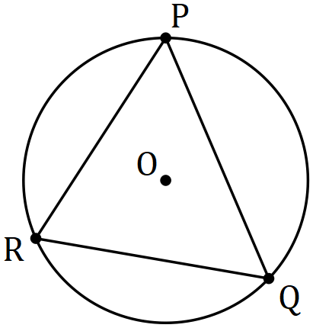

|  |
| --- |
| **Solution** |
|  |
| **Specific behaviours** |
| ✓ indicates size of  ✓ correct |

(b) In the diagram below, is tangent to the circle with centre at , secant intersects the circle at and , and the sizes of angles and are and respectively. Determine the size of angle . (4 marks)

|  |
| --- |
| **Solution** |
| Using : |
| **Specific behaviours** |
| ✓ correct  ✓ correct  ✓ indicates is right-angle  ✓ correct |

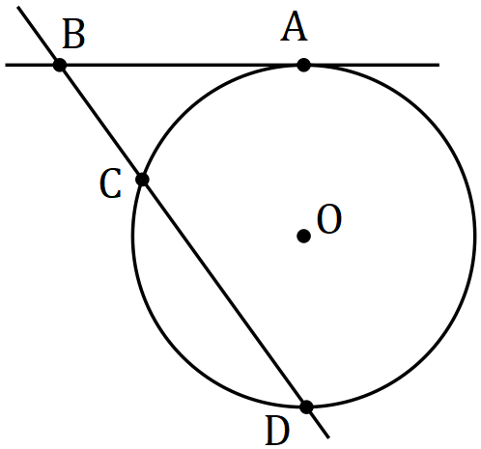

Question 11 (8 marks)

(a) Show how to express as a rational number. (2 marks)

|  |
| --- |
| **Solution** |
| If then  Hence by subtraction , which is rational. |
| **Specific behaviours** |
| ✓ expresses as and  ✓ uses subtraction to express as rational |

(b) Prove that the sum of any three consecutive integers is always a multiple of three.

(3 marks)

|  |
| --- |
| **Solution** |
| Let the integers be and their sum be .  Hence is always a multiple of . |
| **Specific behaviours** |
| ✓ clearly indicates three consecutive integers  ✓ creates sum  ✓ factors out and makes conclusion |

(c) Prove by contradiction that is irrational. (3 marks)

|  |
| --- |
| **Solution** |
| Assume that is rational and can be expressed in the form , where a and b are integers with **no common factor** greater than .  , so that and hence a must be a multiple of .  Since (k an integer) then , so that and hence b must be a multiple of .  Since a and b are both multiples of , the assumption they have no common factor is contradicted and so must be irrational. |
| **Specific behaviours** |
| ✓ makes rational assumption including bolded condition  ✓ deduces that a and must both be multiples of  ✓ explains contradiction |

Question 12 (8 marks)

Let vector .

(a) Determine the angle between and . (1 mark)

|  |
| --- |
| **Solution** |
| Using CAS |
| **Specific behaviours** |
| ✓ correct angle |

(b) Let vector . Determine the value of so that is

(i) parallel to . (2 marks)

|  |
| --- |
| **Solution** |
|  |
| **Specific behaviours** |
| ✓ indicates method  ✓ correct value |

(ii) perpendicular to . (2 marks)

|  |
| --- |
| **Solution** |
|  |
| **Specific behaviours** |
| ✓ indicates method  ✓ correct value |

(c) Determine the vector projection of on . (3 marks)

|  |
| --- |
| **Solution** |
| Let . Then .  Using CAS, |
| **Specific behaviours** |
| ✓ indicates unit vector  ✓ indicates method  ✓ correct projection |

Question 13 (8 marks)

Two matrices are given by and .

(a) Determine . (1 mark)

|  |
| --- |
| **Solution** |
|  |
| **Specific behaviours** |
| ✓ correct product |

(b) Given that , determine the exact value of the constant . (2 marks)

|  |
| --- |
| **Solution** |
|  |
| **Specific behaviours** |
| ✓ uses matrix algebra or states  ✓ correct value |

The system of equations and can be expressed as a matrix equation in the form .

(c) Determine matrices and . (2 marks)

|  |
| --- |
| **Solution** |
|  |
| **Specific behaviours** |
| ✓ correct matrix  ✓ correct matrix |

(d) Express matrix in terms of matrices and . (2 marks)

|  |
| --- |
| **Solution** |
|  |
| **Specific behaviours** |
| ✓ pre-multiplies by  ✓ correct expression |

(e) Solve the system of equations. (1 mark)

|  |
| --- |
| **Solution** |
|  |
| **Specific behaviours** |
| ✓ correct solution |

Question 14 (6 marks)

A segment of a circle has a perpendicular height of and width .

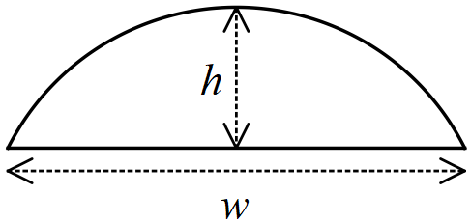

(a) Determine the radius of the arc of the segment when cm and cm. (3 marks)

|  |
| --- |
| **Solution** |
|  |
| **Specific behaviours** |
| ✓ relevant sketch  ✓ uses Pythagoras' Theorem  ✓ correct radius |

(b) Use the intersecting chord theorem to derive a formula for the radius of the arc of a segment of width and height , where the chords are the straight edge of the segment and the diameter of the circle. (3 marks)

|  |
| --- |
| **Solution** |
|  |
| **Specific behaviours** |
| ✓ labelled sketch of intersecting chords  ✓ uses theorem to form equation  ✓ correct formula |

Question 15 (8 marks)

Circle has equation .

(a) Circle is transformed by the matrix to circle . Describe transformation and state the equation of circle . (3 marks)

|  |
| --- |
| **Solution** |
| is a reflection in the line .  Centre:  Equation: |
| **Specific behaviours** |
| ✓ states reflection with equation of line  ✓ identifies new centre  ✓ correct equation |

(b) Circle is then transformed by the matrix to circle . Describe transformation and state the equation of circle . (3 marks)

|  |
| --- |
| **Solution** |
| is a dilation about of scale factor .  Centre:  Equation: |
| **Specific behaviours** |
| ✓ states dilation with scale factor (*dilation centre not required*)  ✓ identifies new centre  ✓ correct equation |

(c) Determine the single matrix that will transform circle back to circle . (2 marks)

|  |
| --- |
| **Solution** |
|  |
| **Specific behaviours** |
| ✓ indicates correct method  ✓ correct matrix |

Question 16 (11 marks)

Two forces act on a body. has a magnitude of N and acts on a bearing of . has a magnitude of N and acts on a bearing of .

(a) Determine

(i) the magnitude and direction of the sum of the two forces. (6 marks)

|  |
| --- |
| **Solution** |
|  |
| **Specific behaviours** |
| ✓ triangle showing sum of two forces  ✓ use of cosine rule with correct angle  ✓ correct magnitude  ✓ indicates use of sine rule  ✓ correct value of  ✓ correct bearing |

|  |
| --- |
| **CAS Solution** |
|  |
| **Specific behaviours** |
| ✓ correct polar angles  ✓ converts to Cartesian  ✓ converts to Cartesian  ✓ adds forces  ✓ converts back to polar  ✓ states magnitude and bearing |

(ii) the magnitude and direction of a third force that would keep the body in equilibrium. (1 mark)

|  |
| --- |
| **Solution** |
|  |
| **Specific behaviours** |
| ✓ correct magnitude and bearing |

(b) The bearing acts on is changed so that the direction of is due east. Determine the new bearing of . (4 marks)

|  |
| --- |
| **Solution** |
|  |
| **Specific behaviours** |
| ✓ diagram  ✓ indicates use of sine rule  ✓ correct values of  ✓ both possible bearings |

Question 17 (8 marks)

A small body moves in a straight line. The displacement of the body from a fixed point is given by , where is in centimetres, is the time in seconds. The graph of against is shown below.

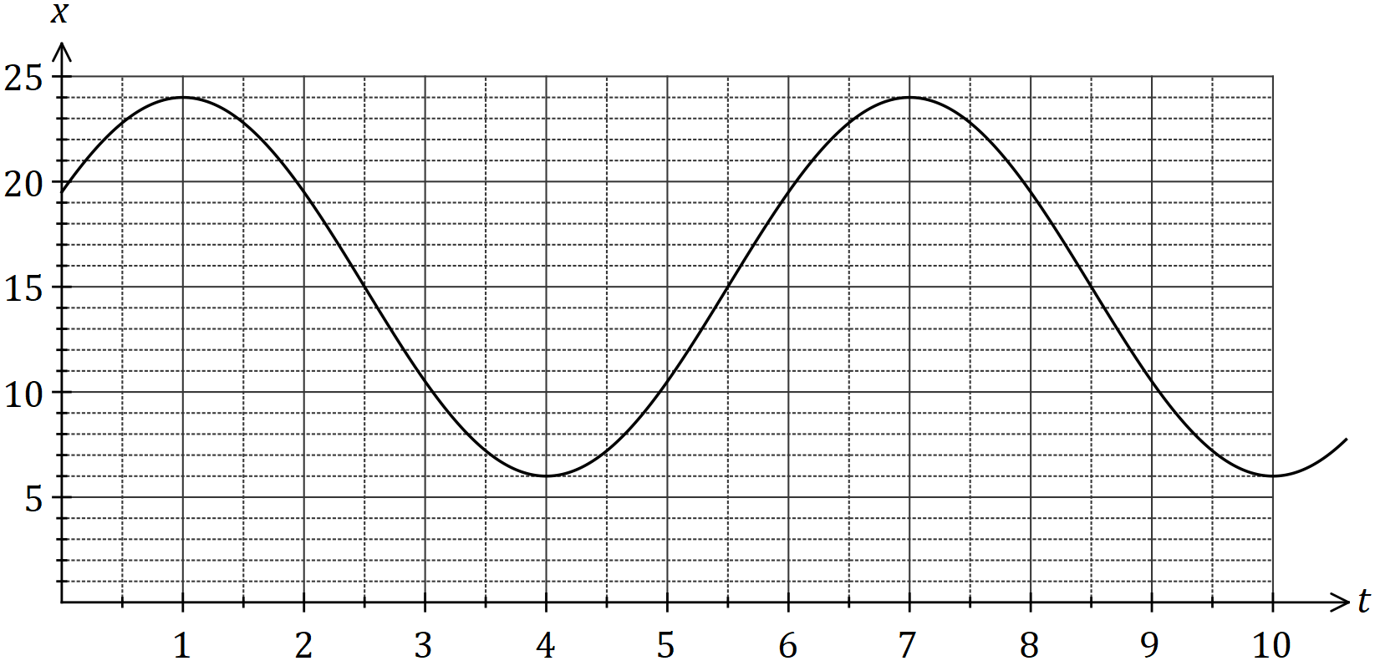

(a) Determine the values of the **positive** constants and . (4 marks)

|  |
| --- |
| **Solution** |
|  |
| **Specific behaviours** |
| ✓ each correct value |

(b) Express the relationship between and as a cosine function. (2 marks)

|  |
| --- |
| **Solution** |
|  |
| **Specific behaviours** |
| ✓ only changes value of  ✓ correct function |

(c) Determine the first time that is cm from after seconds, giving your answer to two decimal places. (2 marks)

|  |
| --- |
| **Solution** |
|  |
| **Specific behaviours** |
| ✓ method  ✓ correct time |

Question 18 (7 marks)

Let .

(a) Three or four-digit codes are to be formed using integers selected from , such as or .

Determine the number of codes that can be formed if

(i) there are no restrictions. (2 marks)

|  |
| --- |
| **Solution** |
|  |
| **Specific behaviours** |
| ✓ indicates number of 3- and 4-digit codes  ✓ correct total |

(ii) no integer may be used more than once in a code. (2 marks)

|  |
| --- |
| **Solution** |
|  |
| **Specific behaviours** |
| ✓ uses permutations for 3- and 4-digit codes  ✓ correct total |

(b) Using the pigeon-hole principle or otherwise, prove that when five integers are selected from at least one pair of the integers will have a sum of . (3 marks)

|  |
| --- |
| **Solution** |
| Partition into pigeon-holes with sums of  If integers (pigeons) are selected from then by the pigeon-hole principle, at least must be in the same pigeon-hole.  Hence at least one pair of the integers will have a sum of . |
| **Specific behaviours** |
| ✓ lists pigeonholes  ✓ uses pigeonhole principle  ✓ makes conclusion |

Question 19 (8 marks)

(a) The four points and lie in that order on the circumference of a circle. Chords and intersect at . Prove that . (4 marks)

|  |  |
| --- | --- |
| **Example solution** | |
|  |  |
| **Specific behaviours** | |
| ✓ labelled diagram  ✓ one pair of equal angles with reason  ✓ second pair of equal angles with reason  ✓ states similarity with reason | |

(b) In triangle , and are the midpoints of and respectively. If and , use a vector method to prove that is a parallelogram. (4 marks)

|  |  |
| --- | --- |
| **Example solution** | |
|  |  |
| Hence is a parallelogram since it has a pair of opposite sides that are parallel and equal in length. | |
| **Specific behaviours** | |
| ✓ labelled diagram  ✓ derives vector for one side of parallelogram  ✓ derives second vector for opposite side  ✓ shows vectors are equal and makes conclusion | |

Question 20 (6 marks)

Use mathematical induction to prove that for all positive integers

|  |
| --- |
| **Solution** |
| Let be the statement  is the statement and so is shown to be true.  Assume is true so that  We have shown that is true and that and so by the principle of mathematical induction it follows that is true. |
| **Specific behaviours** |
| ✓ shows truth of initial case  ✓ clearly states assumption  ✓ adds term to statement, using  ✓ factors out  ✓ completes factorisation  ✓ closing statement |

Question 21 (7 marks)

A small drone is to fly in a straight line and at a constant altitude from to . lies m away from on a bearing of and a steady wind of ms-1 is blowing in the area from due east.

If the speed of the drone is set to ms-1, determine the bearing it should steer and the time that it will take to reach .

|  |
| --- |
| **Solution** |
|  |
| **Specific behaviours** |
| ✓ diagram with key elements  ✓ angle between wind and  ✓ equation using sin rule for  ✓ solves for  ✓ equation using sin rule for  ✓ correct time  ✓ correct bearing |

Supplementary page

Question number: _________

Supplementary page

Question number: _________

Supplementary page

Question number: _________

© 2018 WA Exam Papers. Baldivis Secondary College has a non-exclusive licence to copy and communicate this document for non-commercial, educational use within the school. No other copying, communication or use is permitted without the express written permission of WA Exam Papers. SN261-121-4.